Final Project Screenshots and UML

Contents

Screenshots 1

UML 7

## Screenshots

Login screen

Main menu

Ranking screen

Ranking a game

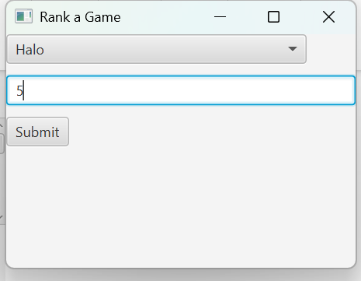

Validate input

Updated main menu

Hours played menu

Validate

Main menu update

Get recommendation

## UML

